Website Development
Assignment 2
My name: Luke Brown

Contents

1.0 Introduction 3
2.0 Client and User needs 3
3.0 Identified client and user needs 3
4.0 Designs 4
4.1. Page layouts 4
4.2. Page content 4
4.3. Assets table 4
4.4. Navigation plan 4
5.0 Technologies 4
6.0 Mark-up and scripting 4
7.0 Languages 4
10.0 Appendix 4
Appendix A – Website Screenshots 4
Appendix B – Questionnaire 4
Appendix C – Questionnaire Results 5
Appendix D – Persona 5
Appendix E – Client Specifications 5

Introduction

This report contains the design of the website for a company called D.A.C. Games and is being used to show off their new game and all of the people behind the development of the game, and has form for people to apply for a role at the company if they want. The report will cover the over the design process and how I listened to the client and tried to implement them into the website.

Client and User needs

The client needs are that the website must have at least 5 pages with a working nav bar to search through the all of the pages easily the pages that the client wants are a home page, staff page, training courses page, about page and a contact page. The contact page has a form to fill out so if the person is interested, they can ask to join the group.

Identified client and user needs

P6 I have review the clients needs and have made a working website with 5 pages (Home, staff, training courses, about and contact) and this is what the client wanted in the website. In the home page there is a

Designs

Page layouts

Page 1: Index or Homepage
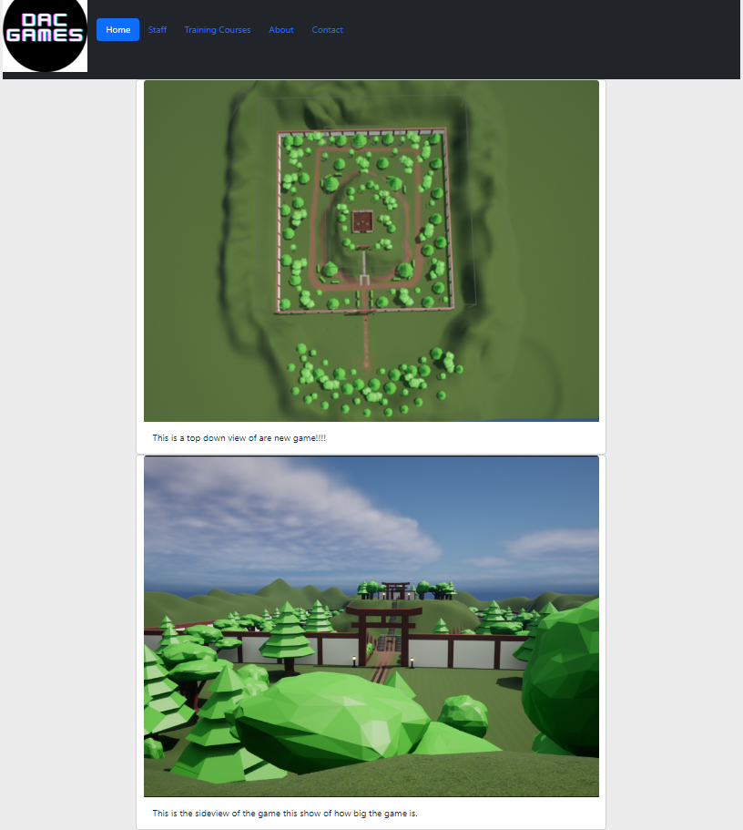

Page 2: staff
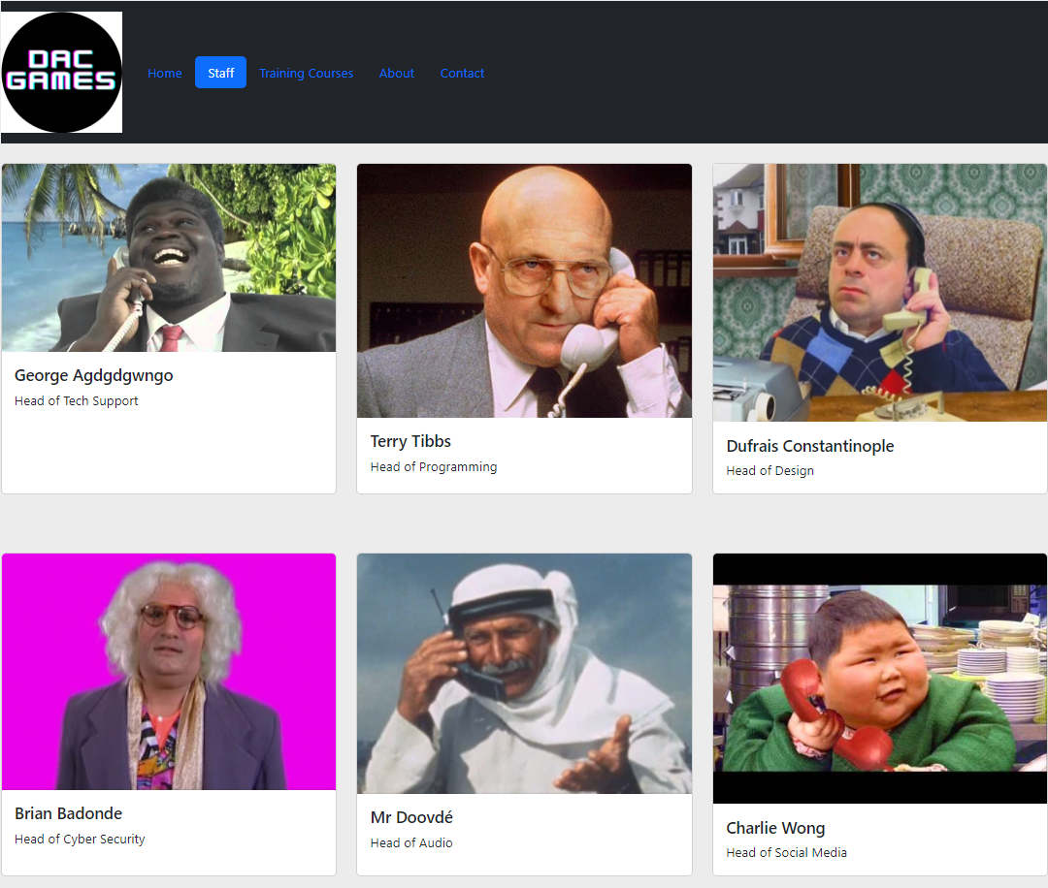
Page 3: training courses

Assets table

Asset Name | Asset Purpose
Logo.jpg | Logo for business identification
game images | Images needed for products
Index.html | Homepage for website
Staff.html | Staff page
Trainingcourse.html | Training courses page
About.html | About page
Contacts.html | Contacts page
Staff images | Images for staff

Navigation plan


Test table
test | Expected outcome | Actual outcome | Action required | Completed
Home page about link | Links to about page | Links to contact page | Update link to correct link | Yes
Home page staff link | Links to staff page | Links to about page | Update link to correct link | Yes
Home page training courses link | Links to training courses page | Links to contact page | Update link to correct link | Yes
Home page contact link | Links to contact page | Links to home page | Update link to correct link | Yes

test | Expected outcome | Actual outcome | Action required | Completed
Staff page home link | Links to home page | Links to about page | Update link to correct link | Yes

test | Expected outcome | Actual outcome | Action required | Completed
Training courses page home link | Links to home page | Links to contact page | Update link to correct link | Yes

test | Expected outcome | Actual outcome | Action required | Completed
About page home link | Links to home page | Links to contact page | Update link to correct link | Yes

test | Expected outcome | Actual outcome | Action required | Completed
contact page home link | Links to home page | Links to contact page | Update link to correct link | Yes

Technologies

Mark-up and scripting
HTML
CSS
PHP

Appendix

Appendix A – Website Screenshots Designs

Appendix B – Questionnaire
https://forms.office.com/Pages/ResponsePage.aspx?id=0JsvSSEvbkyhotOQXlsYc1R6Fv3p2-tCl2SqTvo2b1hUOThZWTRCNUNKWTNURzc5TU8xTDhGSTZWTi4u
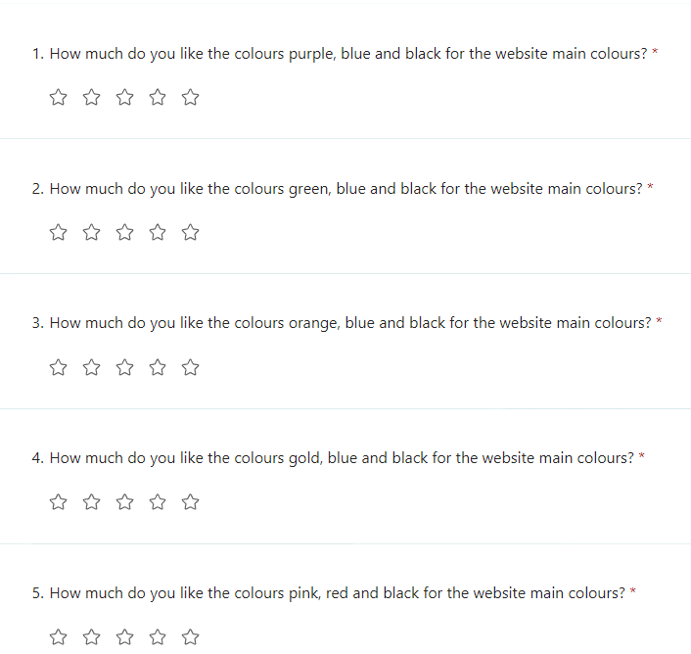
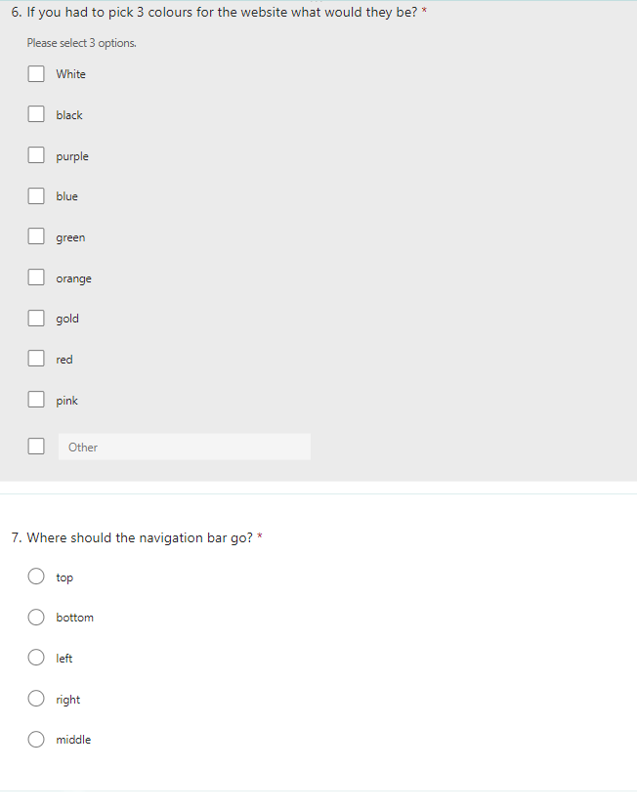

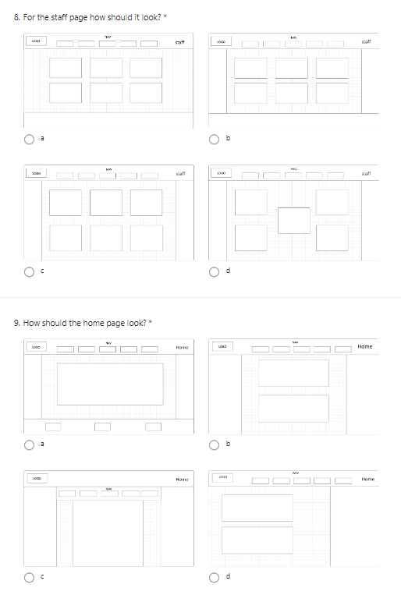
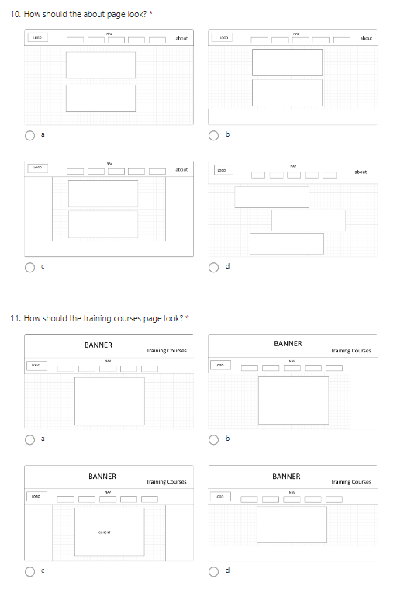

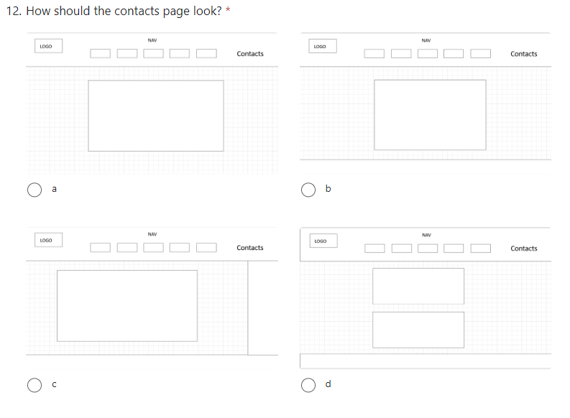

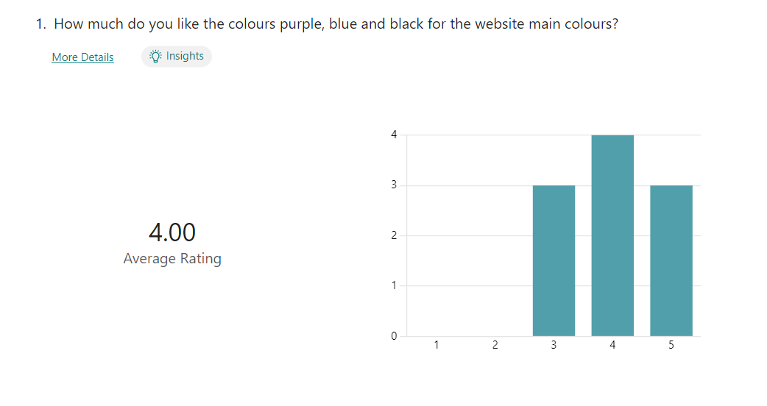
Appendix C – Questionnaire Results
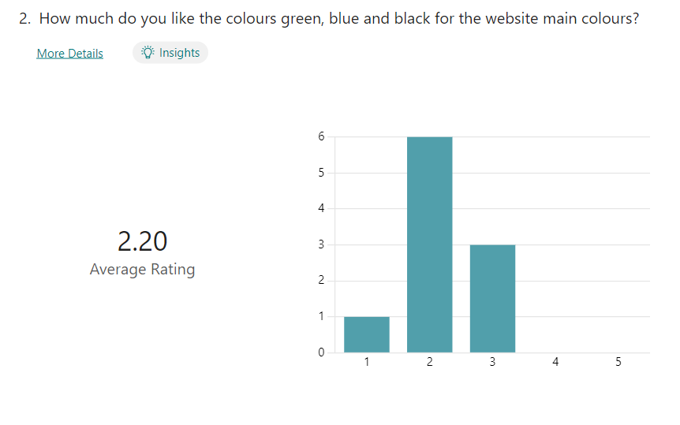

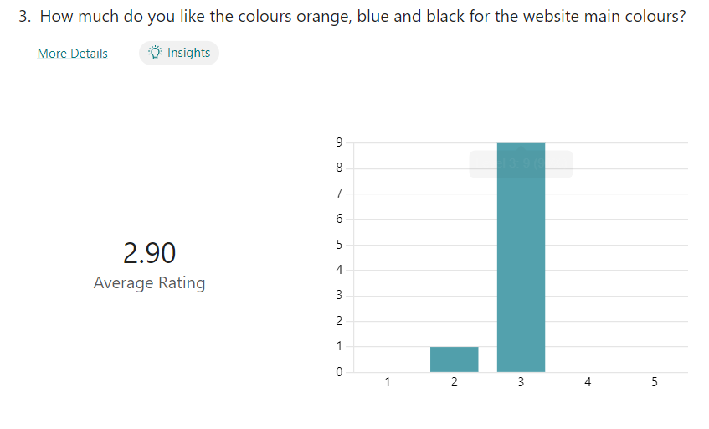
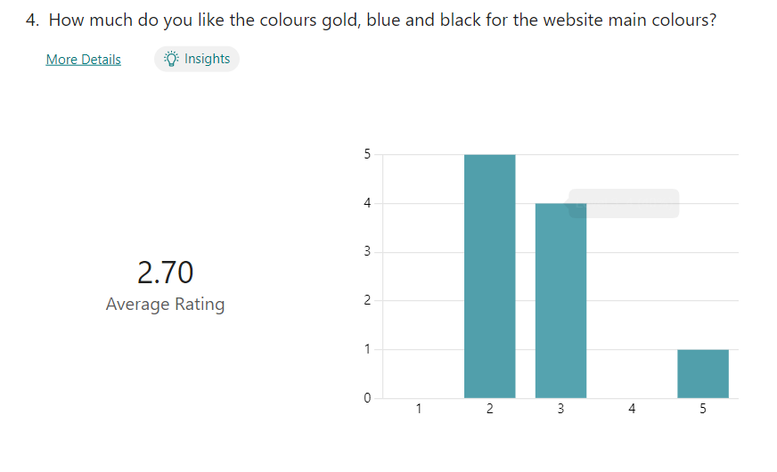

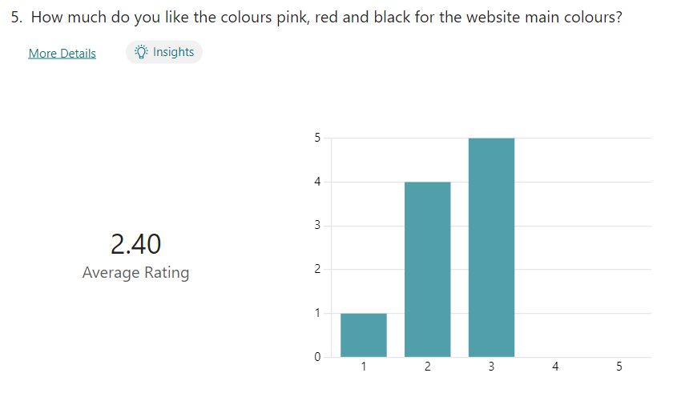
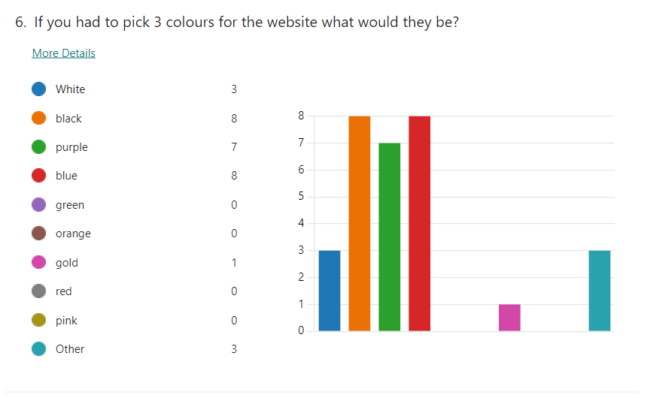
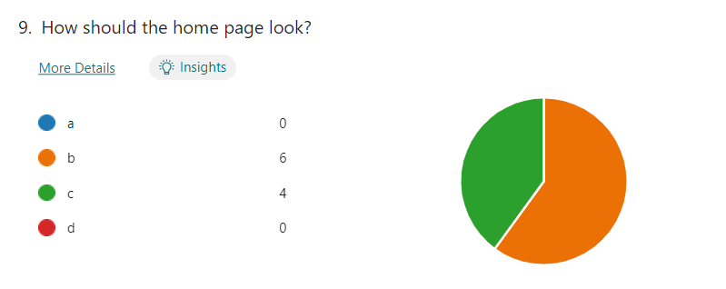
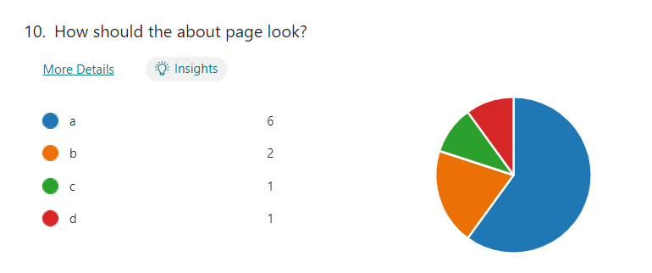

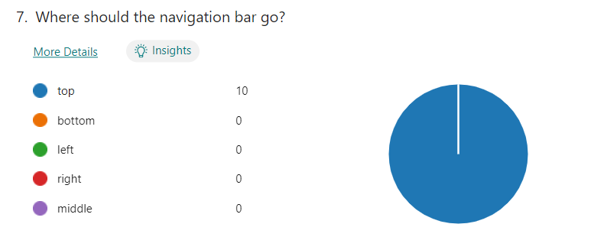
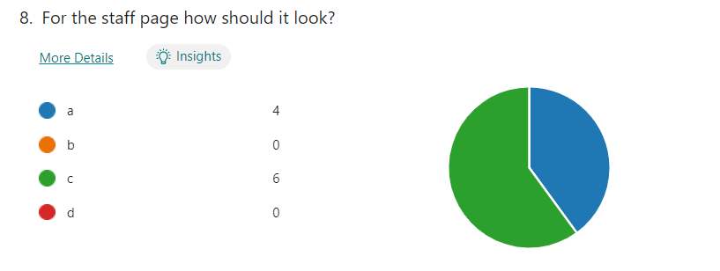

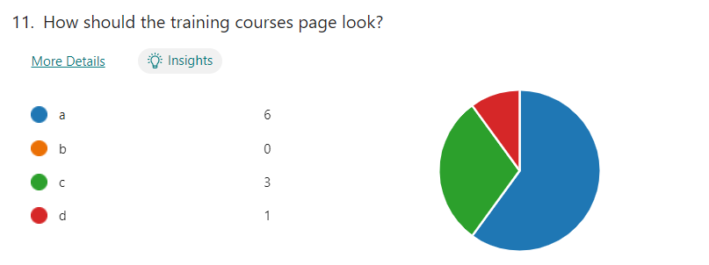
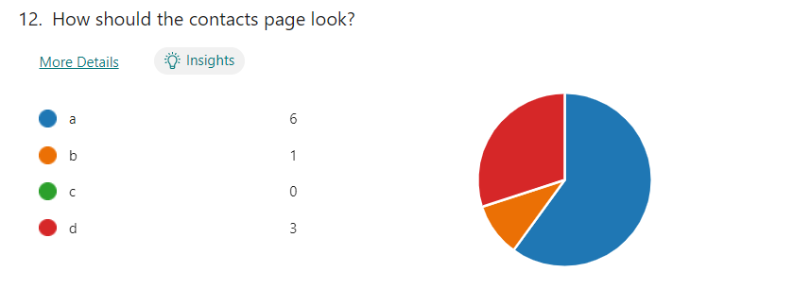

Appendix D – Persona


Appendix E – Client Specifications

Must Have | Should Have | Could Have | Wont Have
- Have 5 pages  - Home page | - Contact info | - Login System  - Crypto-Currencies | - Google Payment

Appendix F – Website
Wireframes
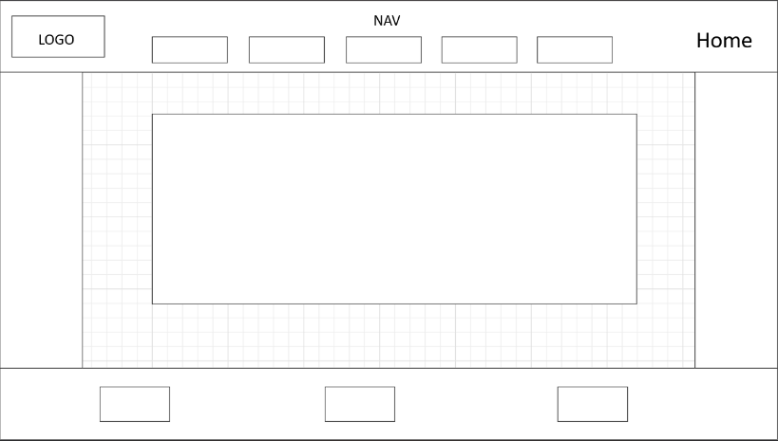
Home wireframes
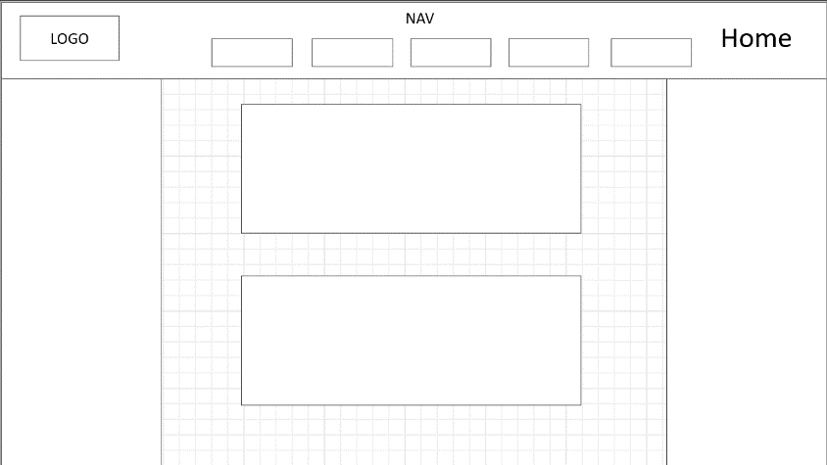

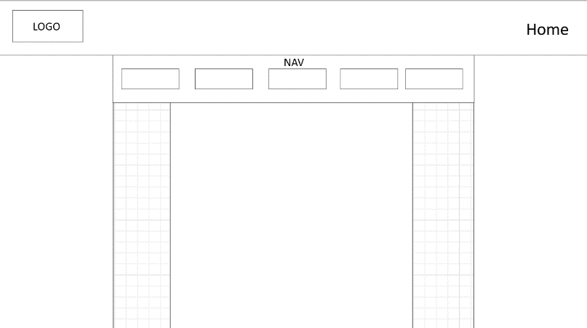
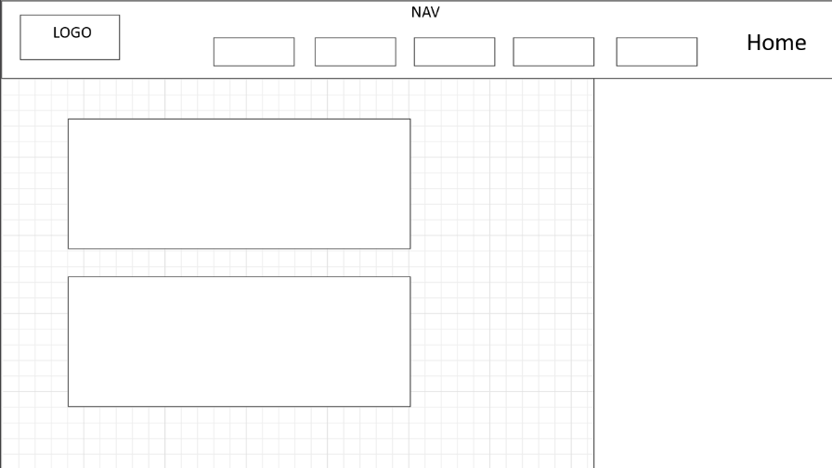

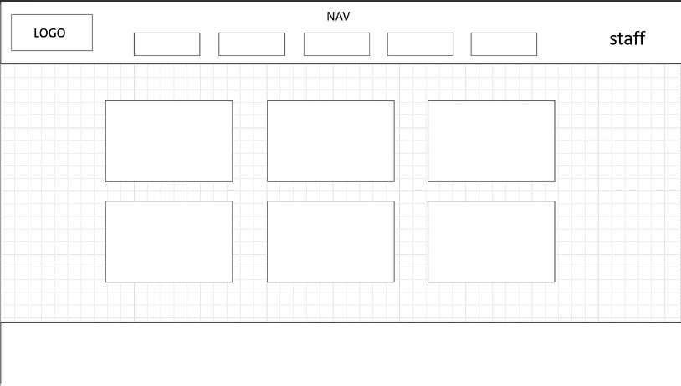
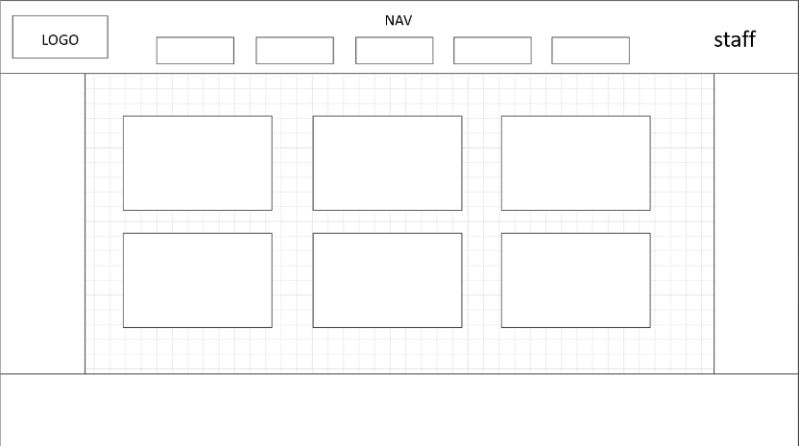
Staff wireframes

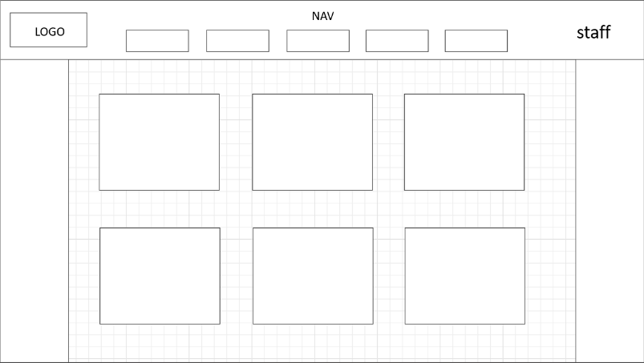
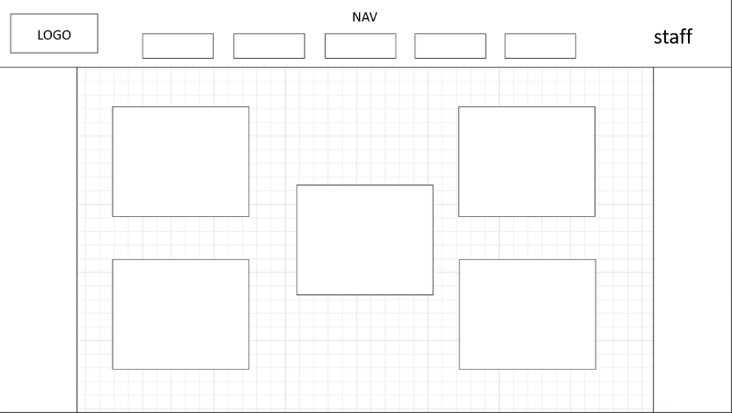

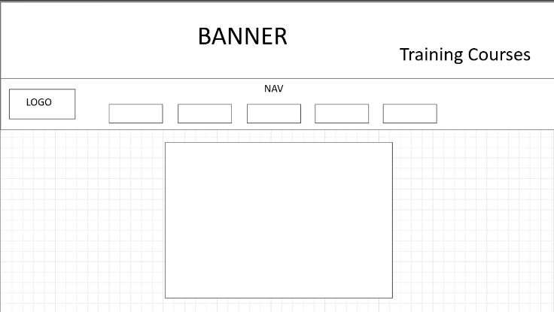
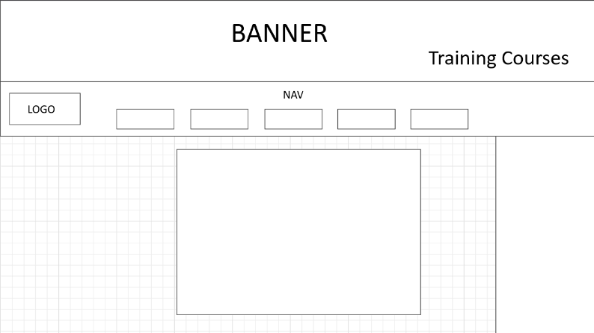
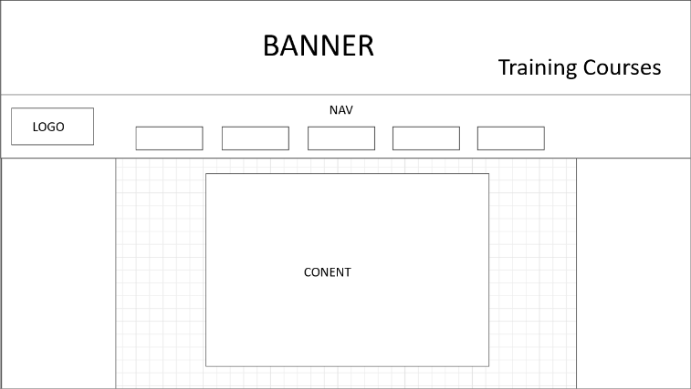
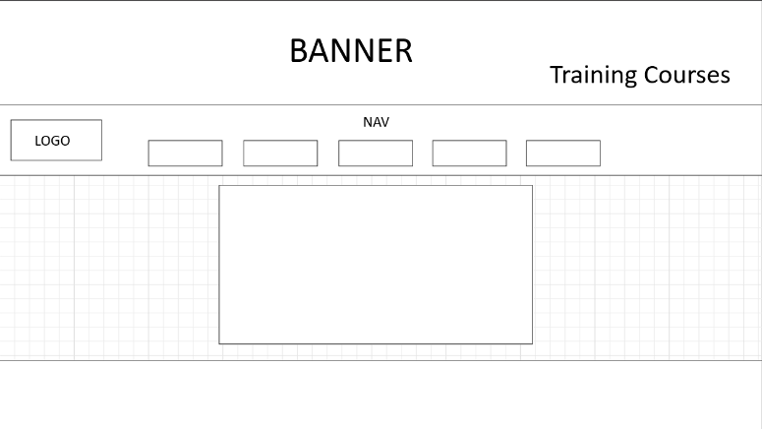
Training courses wireframes

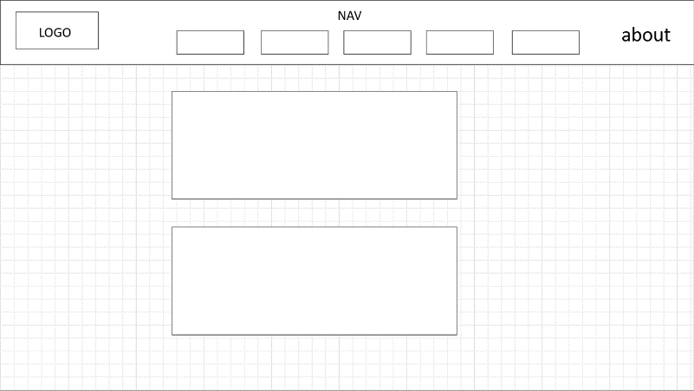
About wireframes
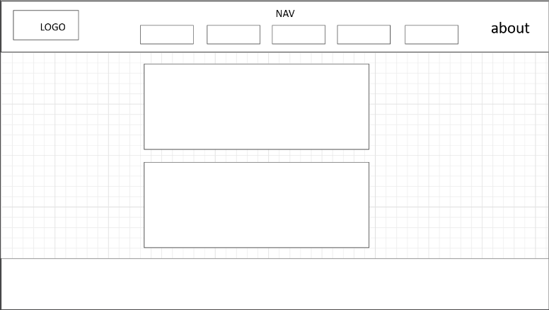

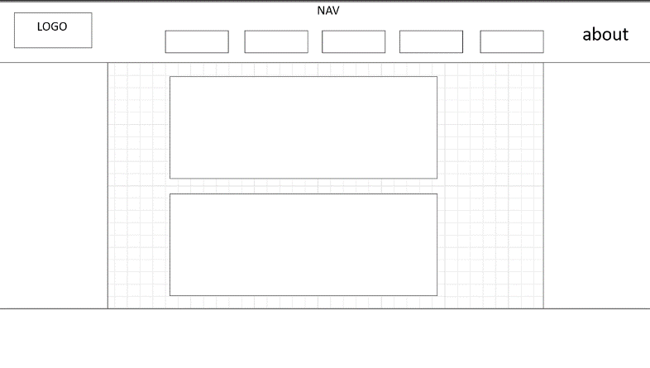
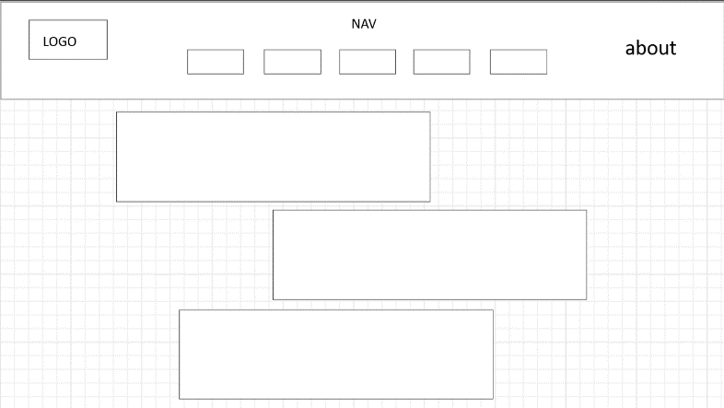

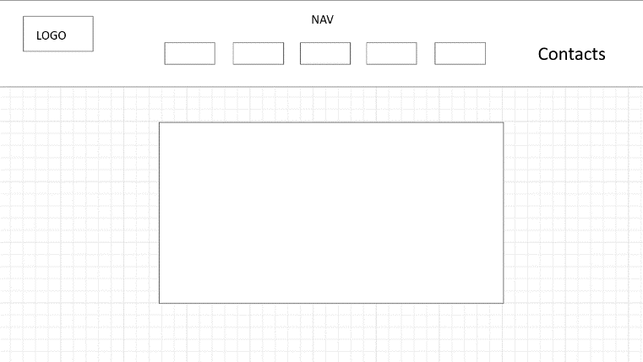
Contacts wireframes
